DATA PREPROCESSING

AIM:
To load a dataset using Pandas, check and handle missing values, select numerical columns, and normalize the data using StandardScaler from Scikit-learn.

ALGORITHM:
- Start the program.
- Import the Pandas library and StandardScaler from Scikit-learn.
- Load the dataset from the CSV file data.csv.
- Display the first five rows of the original dataset.
- Check and display the missing values in each column.
- Fill missing numerical values with the mean of their respective columns.
- Select the numerical columns: Hours_Studied, Attendance, Assignments, and Marks.
- Apply StandardScaler to normalize the selected data.
- Convert the normalized data into a Pandas DataFrame.
- Display the first five rows of the normalized dataset.
- Stop the program.

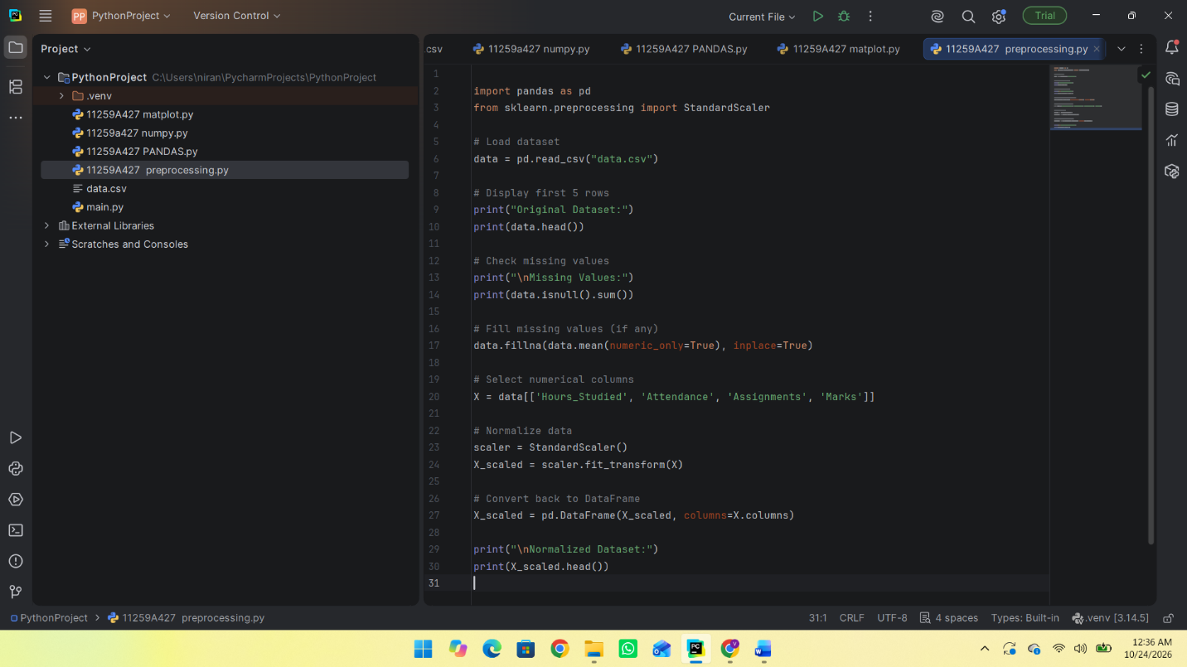

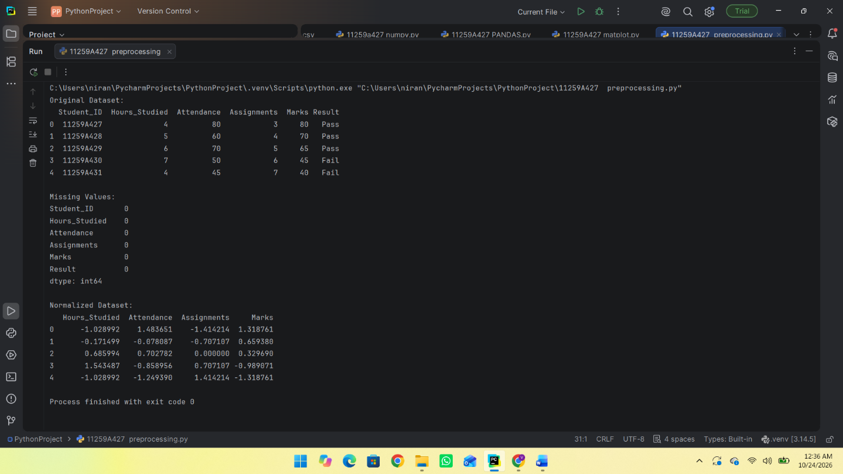

RESULT:
Thus, the dataset was successfully loaded, missing values were checked and handled, and the selected numerical columns were normalized using StandardScaler. The normalized dataset was displayed successfully.

